**DAILY ONLINE ACTIVITIES SUMMARY**

|  |  |  |  |  |  |  |  |  |
| --- | --- | --- | --- | --- | --- | --- | --- | --- |
| **Date:** | **24-06-2020** | | | | | **Name:** | **Anusha** | |
| **Sem & Sec** | **VIII Semester & A Section** | | | | | **USN:** | **4AL16CS014** | |
| **Online Test Summary** | | | | | | | | |
| **Subject** | | **-** | | | | | | |
| **Max. Marks** | | **-** | | **Score** | | | **-** | |
| **Certification Course Summary** | | | | | | | | |
| **Course** | **Introduction to EC2 Auto Scalling** | | | | | | | |
| **Certificate Provider** | | | **Amazon Web Service** | | **Duration** | | | **10 minutes** |
| **Coding Challenges** | | | | | | | | |
| **Problem Statement: Write a program to merge two sorted arrays.** | | | | | | | | |
| **Status: COMPLETED** | | | | | | | | |
| **Uploaded the report in Github** | | | | | **YES** | | | |
| **If yes Repository name** | | | | | **anushasuvarna-014** | | | |
| **Uploaded the report in slack** | | | | | **YES** | | | |

Online Test Details:

NIL

Certification Course 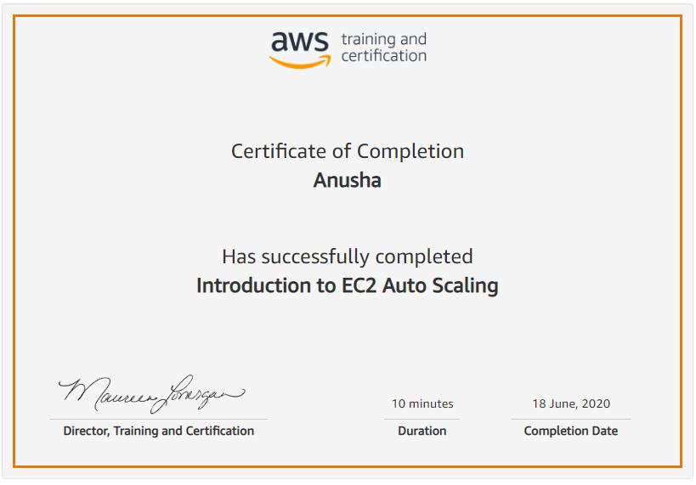

Coding Challenges Details:

|  |
| --- |
|  |
|  |
|  |
|  |
|  |
|  |
|  |
|  |
|  |
|  |
|  |
|  |
|  |
|  |
|  |
|  |
|  |
|  |
|  |
|  |
|  |
|  |
|  |
|  |
|  |
|  |
|  |
|  |
|  |
|  |
|  |
|  |
|  |
|  |
|  |
|  |
|  |
|  |
|  |
|  |
|  |
|  |
|  |
|  |
|  |
|  |
|  |
|  |
|  |
|  |
|  |
|  |
|  |
|  |

**Program1:**

|  |  |
| --- | --- |
|  |  |

**#include <stdio.h>**

**#include <stdlib.h>**

**int merge_two_sorted_arrays(int arr1[], int arr2[], int arr3[], int m, int n)**

**{**

**int i,j,k;**

**i = j = k = 0;**

**for(i=0;i < m && j < n;)**

**{**

**if(arr1[i] < arr2[j])**

**{**

**arr3[k] = arr1[i];**

**k++;**

**i++;**

**}**

**else**

**{**

**arr3[k] = arr2[j];**

**k++;**

**j++;**

**}**

**}**

**while(i < m)**

**{**

**arr3[k] = arr1[i];**

**k++;**

**i++;**

**}**

**while(j < n)**

**{**

**arr3[k] = arr2[j];**

**k++;**

**j++;**

**}**

**}**

**int main()**

**{**

**int n,m;**

**printf("\nEnter the size of Array 1 : ");**

**scanf("%d",&m);**

**printf("\nEnter the size of Array 2 : ");**

**scanf("%d",&n);**

**int arr1[m],arr2[n];**

**int arr3[m+n];**

**int i;**

**printf("\nInput the Array 1 elements : ");**

**for(i = 0; i < m; i++)**

**{**

**scanf("%d",&arr1[i]);**

**}**

**printf("\nInput the Array 2 elements : ");**

**for(i = 0;i<n;i++)**

**{**

**scanf("%d",&arr2[i]);**

**}**

**merge_two_sorted_arrays(arr1,arr2,arr3,m,n);**

**printf("\nThe Merged Sorted Array : ");**

**for(i = 0; i < n + m; i++)**

**{**

**printf("%d ",arr3[i]);**

**}**

**printf("\n");**

**return 0;**

**}**